**PIZZA SALES ANALYSIS**

1. **KPI’S**
2. **Total Revenue**

**SELECT sum(total_price) AS "Total Revenue"**

**FROM pizza_sales**



1. **Average Order Value**

**SELECT (sum(total_price) / count(distinct(order_id))) AS "Avg Order Value"**

**FROM pizza_sales;**



1. **Total Pizza Sold**

**SELECT SUM(quantity) as "Total Pizza Sold" FROM pizza_sales**



1. **Total Orders Placed**

**SELECT count(distinct(order_id)) AS "Total Order Placed" from pizza_sales**



1. **Average Pizza Per order**

**SELECT round(sum(quantity)/ count(distinct(order_id)),2) AS "Avg Pizza Per Order"**

**FROM pizza_sales**



1. **Daily Trend for Total Orders**

**SELECT dayname(order_date) as "order day", count(distinct(order_id)) as "Total Orders"**

**from pizza_sales**

**group by dayname(order_date)**

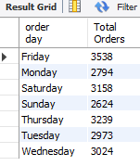

1. **Hourly Trends**

**SELECT hour(order_time) as order_hours, count(distinct(order_id)) as Total_orders**

**from pizza_sales**

**group by hour(order_time)**

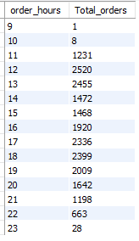

1. **Percentage Of Sales by Pizza Category**

**SELECT**

**pizza_category,**

**round(sum(total_price),2) as Total_Sale,**

**round(SUM(total_price) * 100 / (SELECT SUM(total_price) FROM pizza_sales WHERE month(order_date) = 1),2 ) AS percentage**

**FROM**

**pizza_sales**

**WHERE month(order_date) = 1**

**GROUP BY**

**pizza_category;**

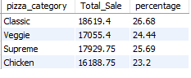

**SELECT**

**pizza_category,**

**round(sum(total_price),2) as Total_Sale,**

**round(SUM(total_price) * 100 / (SELECT SUM(total_price) FROM pizza_sales),2) AS percentage**

**FROM**

**pizza_sales**

**WHERE**

**month(order_date) = 1**

**GROUP BY**

**pizza_category;**

*\*Here MONTH(order_date) = 1 indicates that the output is for the month of January. MONTH(order_date) = 4 indicates output for Month of April.*

1. **Percentage of Sales by Pizza Size**

**SELECT pizza_size, round(sum(total_price),2), round(sum(total_price)*100/(select sum(total_price) from pizza_sales),2) as percent_sales**

**from pizza_sales**

**group by pizza_size**

**order by percent_sales desc**

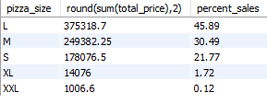

1. **Total Pizza sold by pizza Category**

**SELECT pizza_category, sum(quantity) as Total_Pizza**

**from pizza_sales**

**group by pizza_category**

**order by Total_Pizza desc**

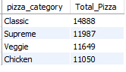

1. **Top 5 Best Seller by Total Pizzas Sold:**

**SELECT pizza_name, sum(quantity) as Total_Pizza_Sold**

**from pizza_sales**

**group by pizza_name**

**order by Total_Pizza_Sold DESC limit 5**

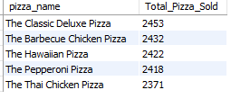

1. **Bottom 5 worst seller by Total Pizza Sold**

**SELECT pizza_name, sum(quantity) as Total_Pizza_Sold**

**from pizza_sales**

**group by pizza_name**

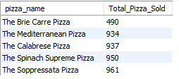**order by Total_Pizza_Sold limit 5**